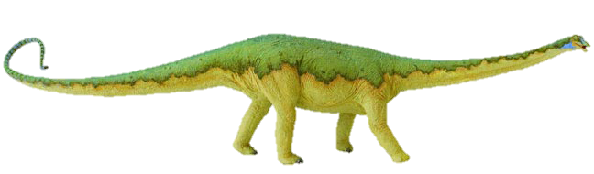
Long and short u sound sort
Sometimes it’s helpful to say that short sounds are short and bouncy, and to make a bouncing ball action as you say them; while long sounds can be stretched, exaggerating the sound slightly, whilst making a stretching elastic kind of movement.
Cut this top row off before you give the sort to pupils!

long vowel |  | 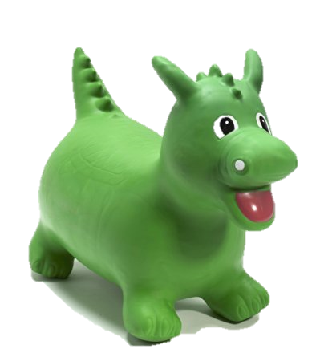  short  vowel
Sort by long or short sound – helps children to look for the single short u grapheme or to see it in combination with other letters to make a digraph with a long sound. | 
hug | mum | bus
fun | sun | rub
puppy | flute | clue
blew | blue | you
loo | moon | smooth
zoo | screw | new
glue | huge | rude
hut | fuss | jug

